**Lab 3: MOSFET**

**Subject: Semiconductor Devices**



**Name: Ahmed Sabry Hamza Eldeeb**

**ID: 19015258**

**Department: Communications**

**Section: 1**

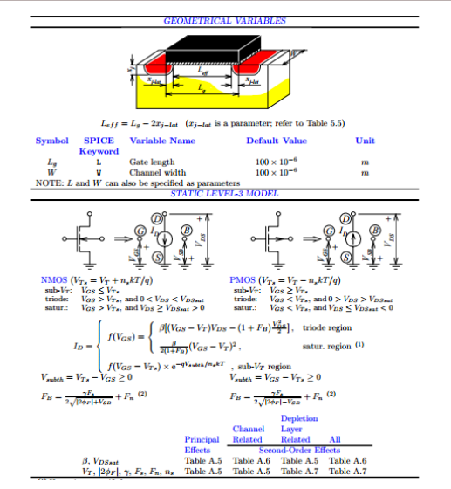

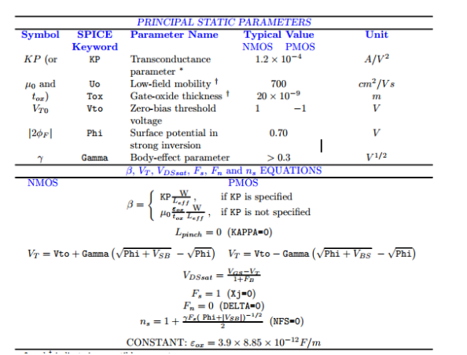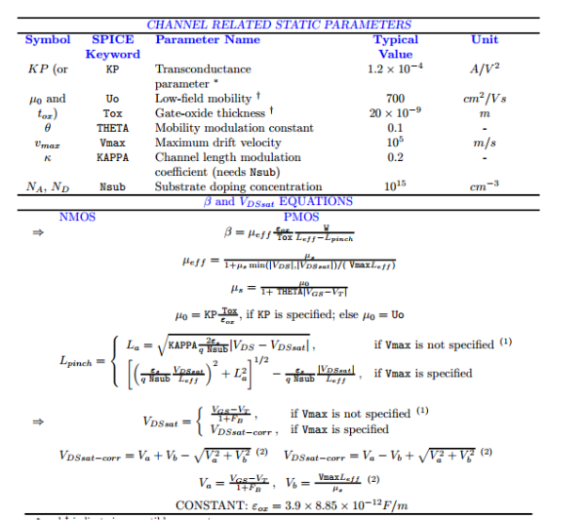

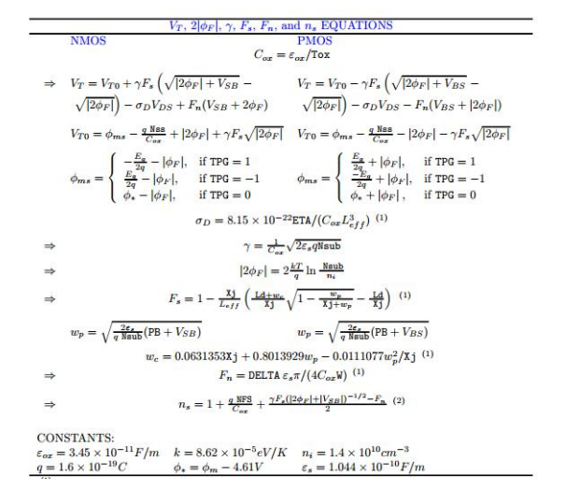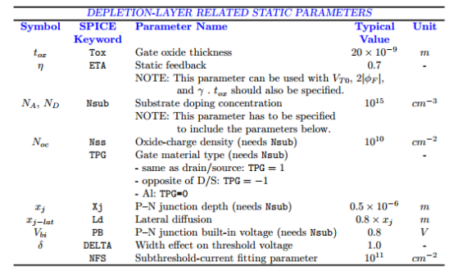

**Procedures**

1- Connect the circuit as shown in the figure, using the Mbreakn

2- Edit the transistor model to LEVEL=3 KP= 20E-6 VTO=0.

3- Run DC sweep of V1 from 0 to 10V with 0.1V step and plot the drain current of the transistor.

* We notice that our transistor is operating in ***Linear region***

4- Make VTO=1 and repeat the previous step.

* We notice that there is no current passes through the MOSFET until  
  Vgs = Vthreshold  which happened when Vgs = 1V.

5- Make KP=100E-6 and repeat step 3, explain the change in the output.

* 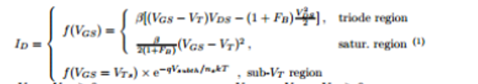Depending on the current relation (in triode mode):  
  we see that current is proportional to the parameter beta   
  and we know that beta is given by this relation:

And beta is proportional to KP as well, then we notice that the current increased five times as well as KP had increased (positive direct relation)

6- Set GAMMA=0 and run DC sweep + parametric sweep on V3 (bulk source voltage) from 0 to 5V with step 1V.

* We notice that all the graphs are identical in this case

7- Set GAMMA=0.6 PHI=0.75 and repeat step 6.

* 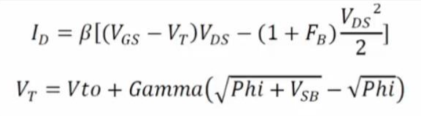We noticed now that the starting point of the triode region of transistor is shifted to the right as we increase the Vbody (VBS in our case) depending on these relations:  
  we can see that current depends on difference between Vgs and VT which will vary in case we have a value of GAMMA which will make the graphs starting point varying.

This phenomenon is called **“Body Effect”**

8- Set GAMMA back to zero, and run primary sweep on VDS from 0V to 10V with 1V step and parametric sweep on **VGS** from 0V to 8V with 2V step.

* We notice that saturation region starts when Vd = Vg  - Vt  , so whenever we increase the value of VGS, then we have a shifted starting point of saturation which means a higher value of current we obtain by just controlling Voltage applied on the gate.

9 - Set GAMMA=0.6 PHI=0.75 and repeat the step 8

* In this case, after applying GAMMA and PHI values, we could notice that level of currents decreased due to the phenomenon of **Body Effect**   
  so the condition of saturation is ***Vd = Vg  - Vt***

10 - Run DC sweep on VGS from 0V to 10V with 1V step and run with it parametric sweep on the parameter THETA = 0 and 0.1.

* We Notice that as Theta increases (from 0 to 0.1), then current decreases,  
  this happens depending on these relations respectively:

***Theta increased***, meos decreases

Meos  decreases, meoeff decreases



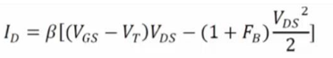Meoeff decreases, BETA decreases

BETA decreases, then finally ***current decreases.***

11 - Repeat step 8 and 9 but this time change the parameter THETA (not gamma) to 0 and 0.1.

**Theta = 0**

**Theta = 0.1**

* We notice that as we said before that when we increasing Theta, then the current is going to be decreased depending on the relations which we have discussed in the previous steps.